**Find, more, less**

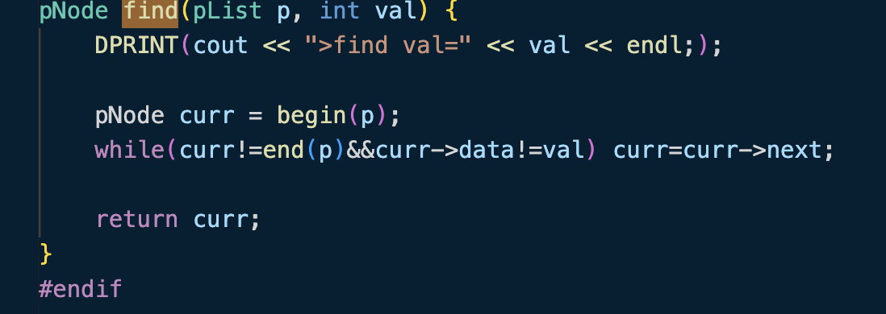

While without if statement

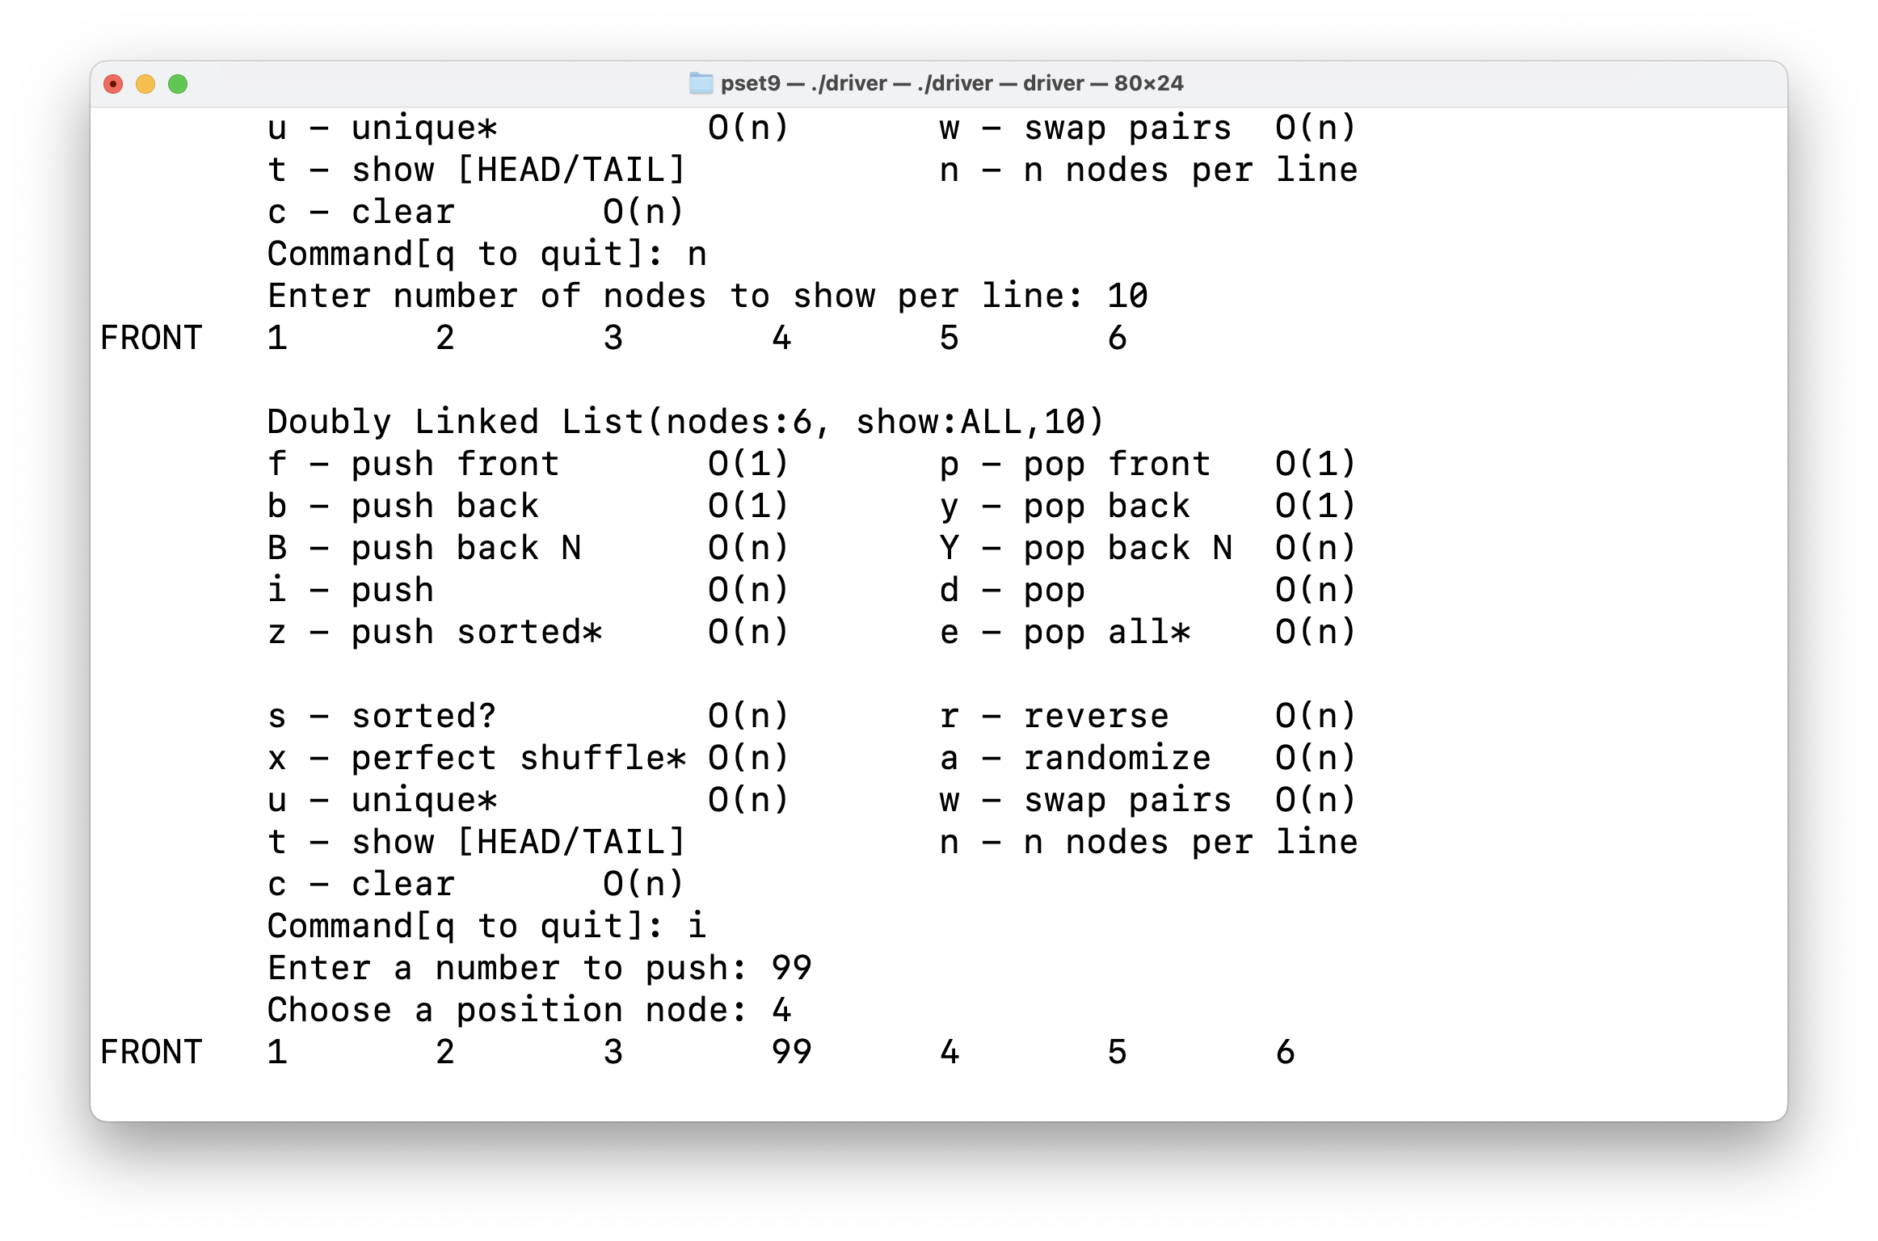

Testing find() with push command(i)

**Push commands, push()**

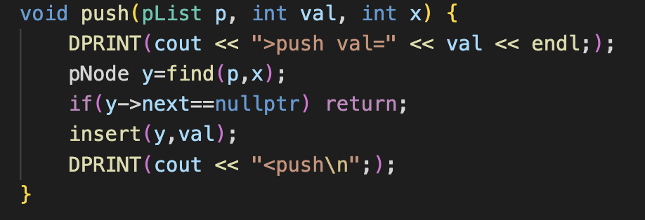

Push() using both find()&insert(), implemented within 3 lines.

By using find(), we can get the target node that has same parameter val.

According to find(), if position is not found, it will return last node. And since last node’s next is   
nullptr, push() doesn’t add a new node and just returns without any actions.

Pop commands, pop_all()

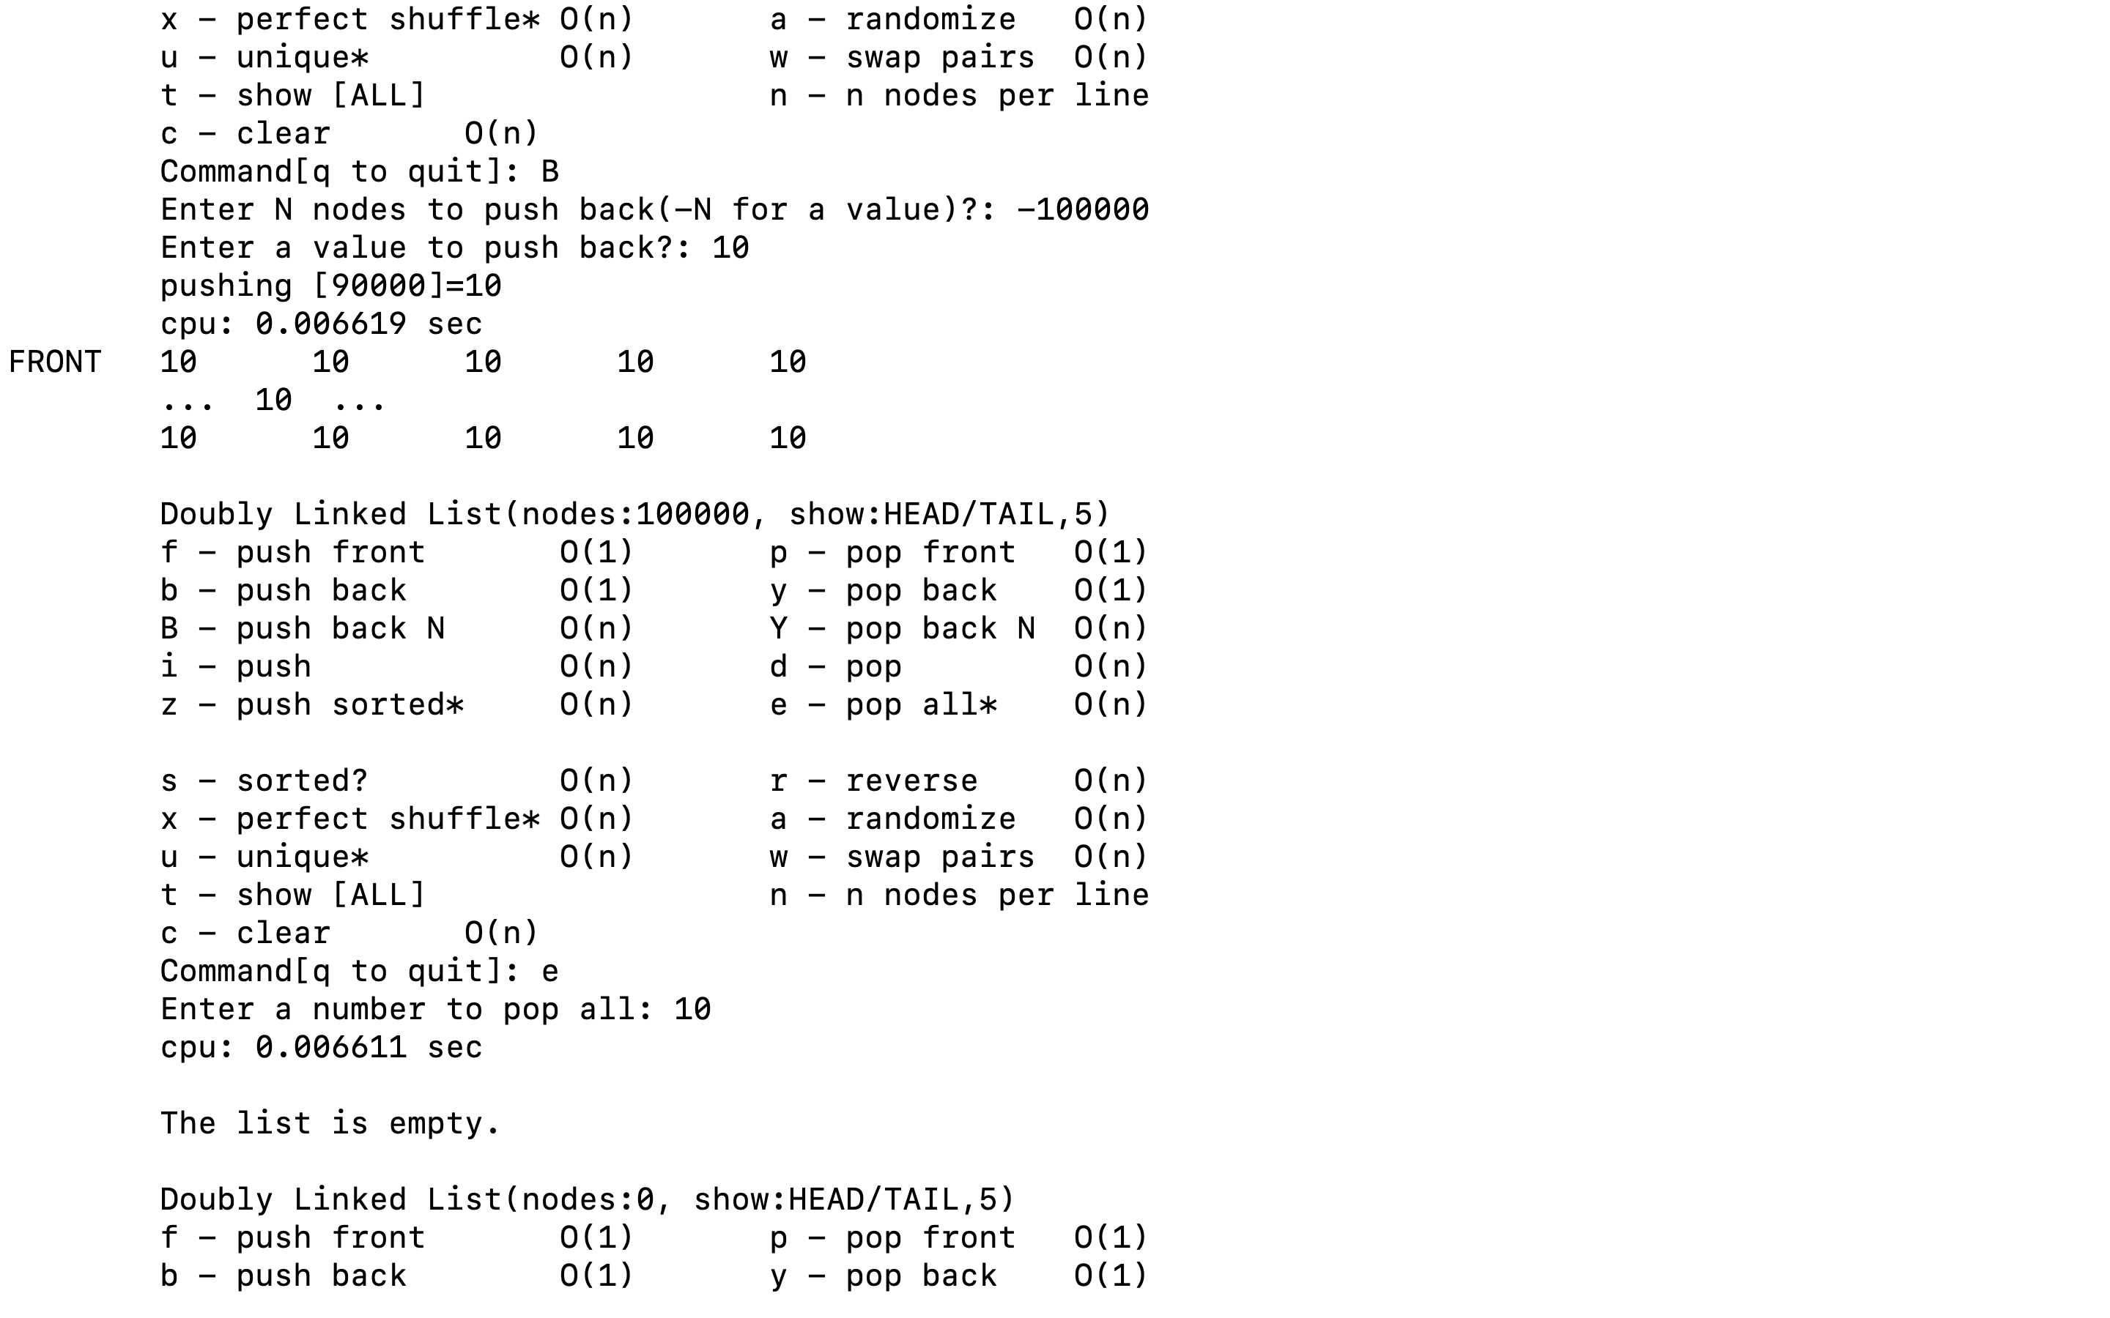

Testing with 100,000 samples

By using pop_all, we can get rid of every number that is same as input number. To fix the bug, I   
temporarily saved the node’s next address before the erase().

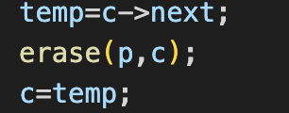

Since erase() deletes c node, I set the c as saved node address. By this way, the bug doesn’t occur anymore.

**Half() and show()**

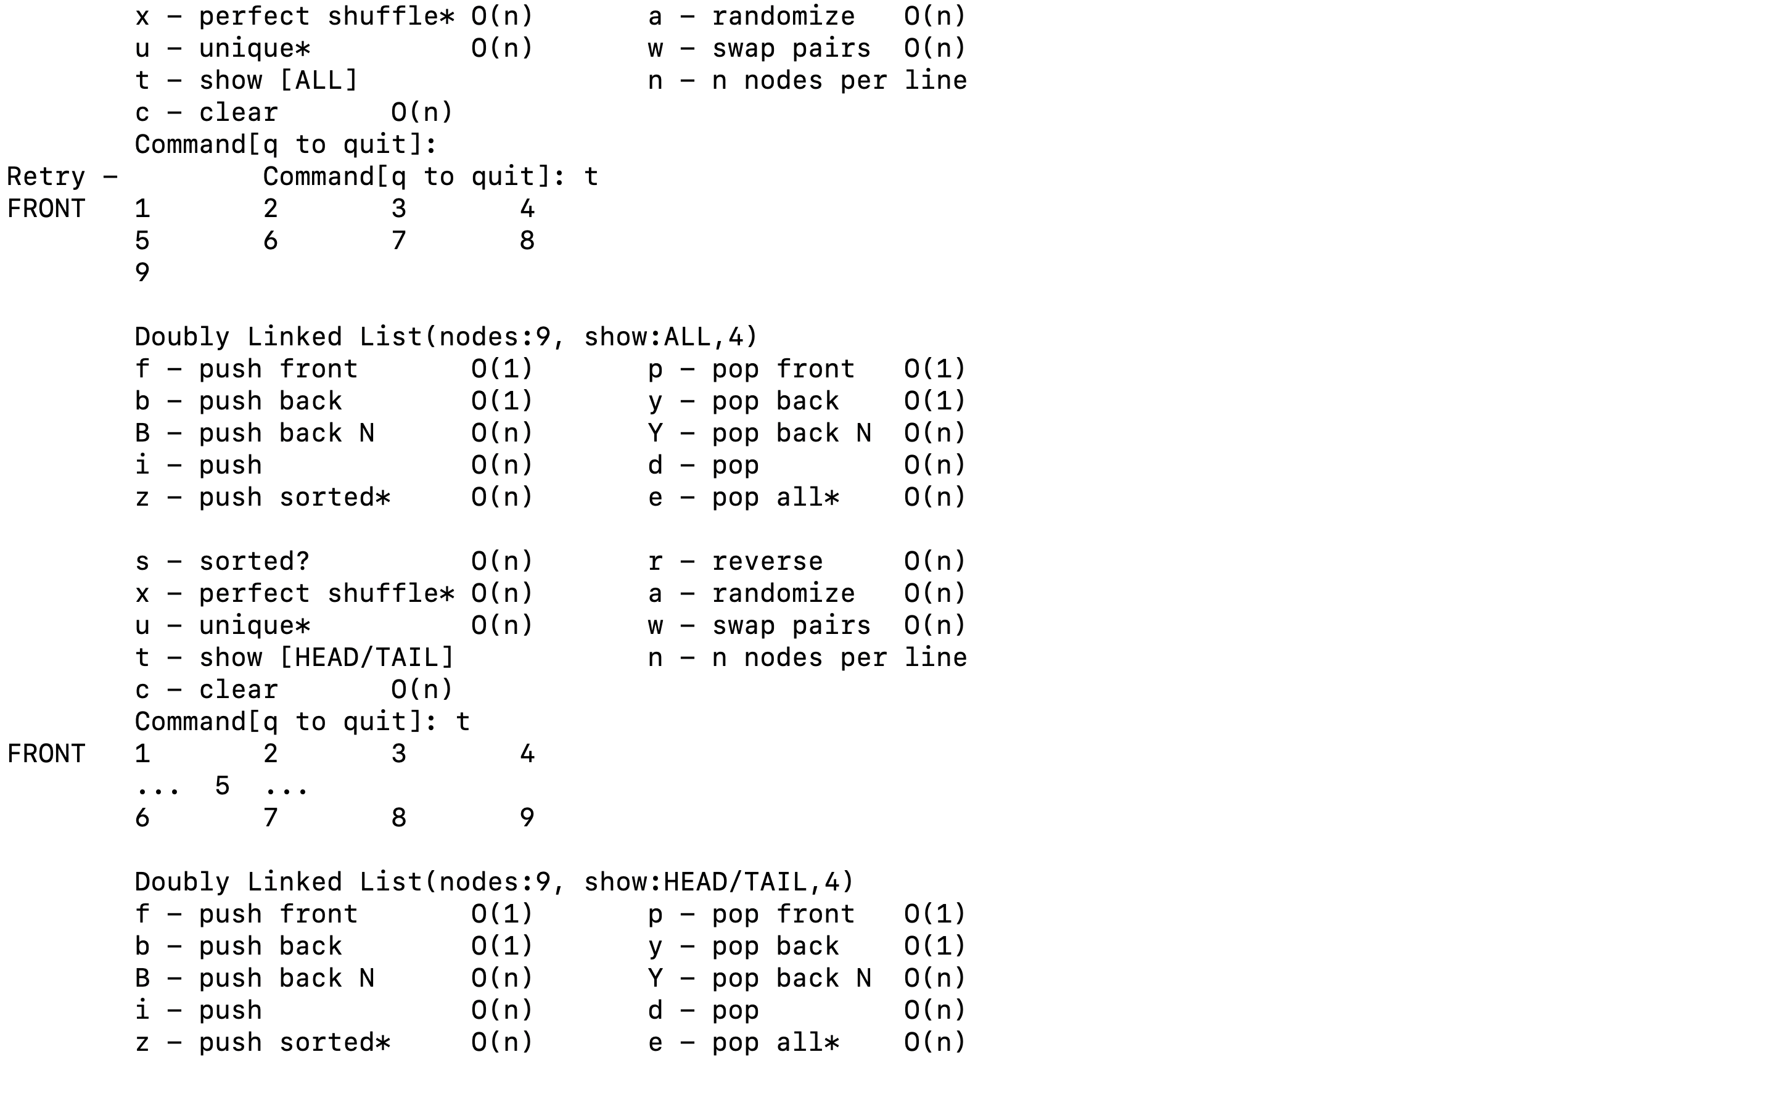

The length of list is 9, and 4 nodes are shown per list in HEAD/TAIL menu.

We can see that it works properly.

What about the case when length of list is even number?

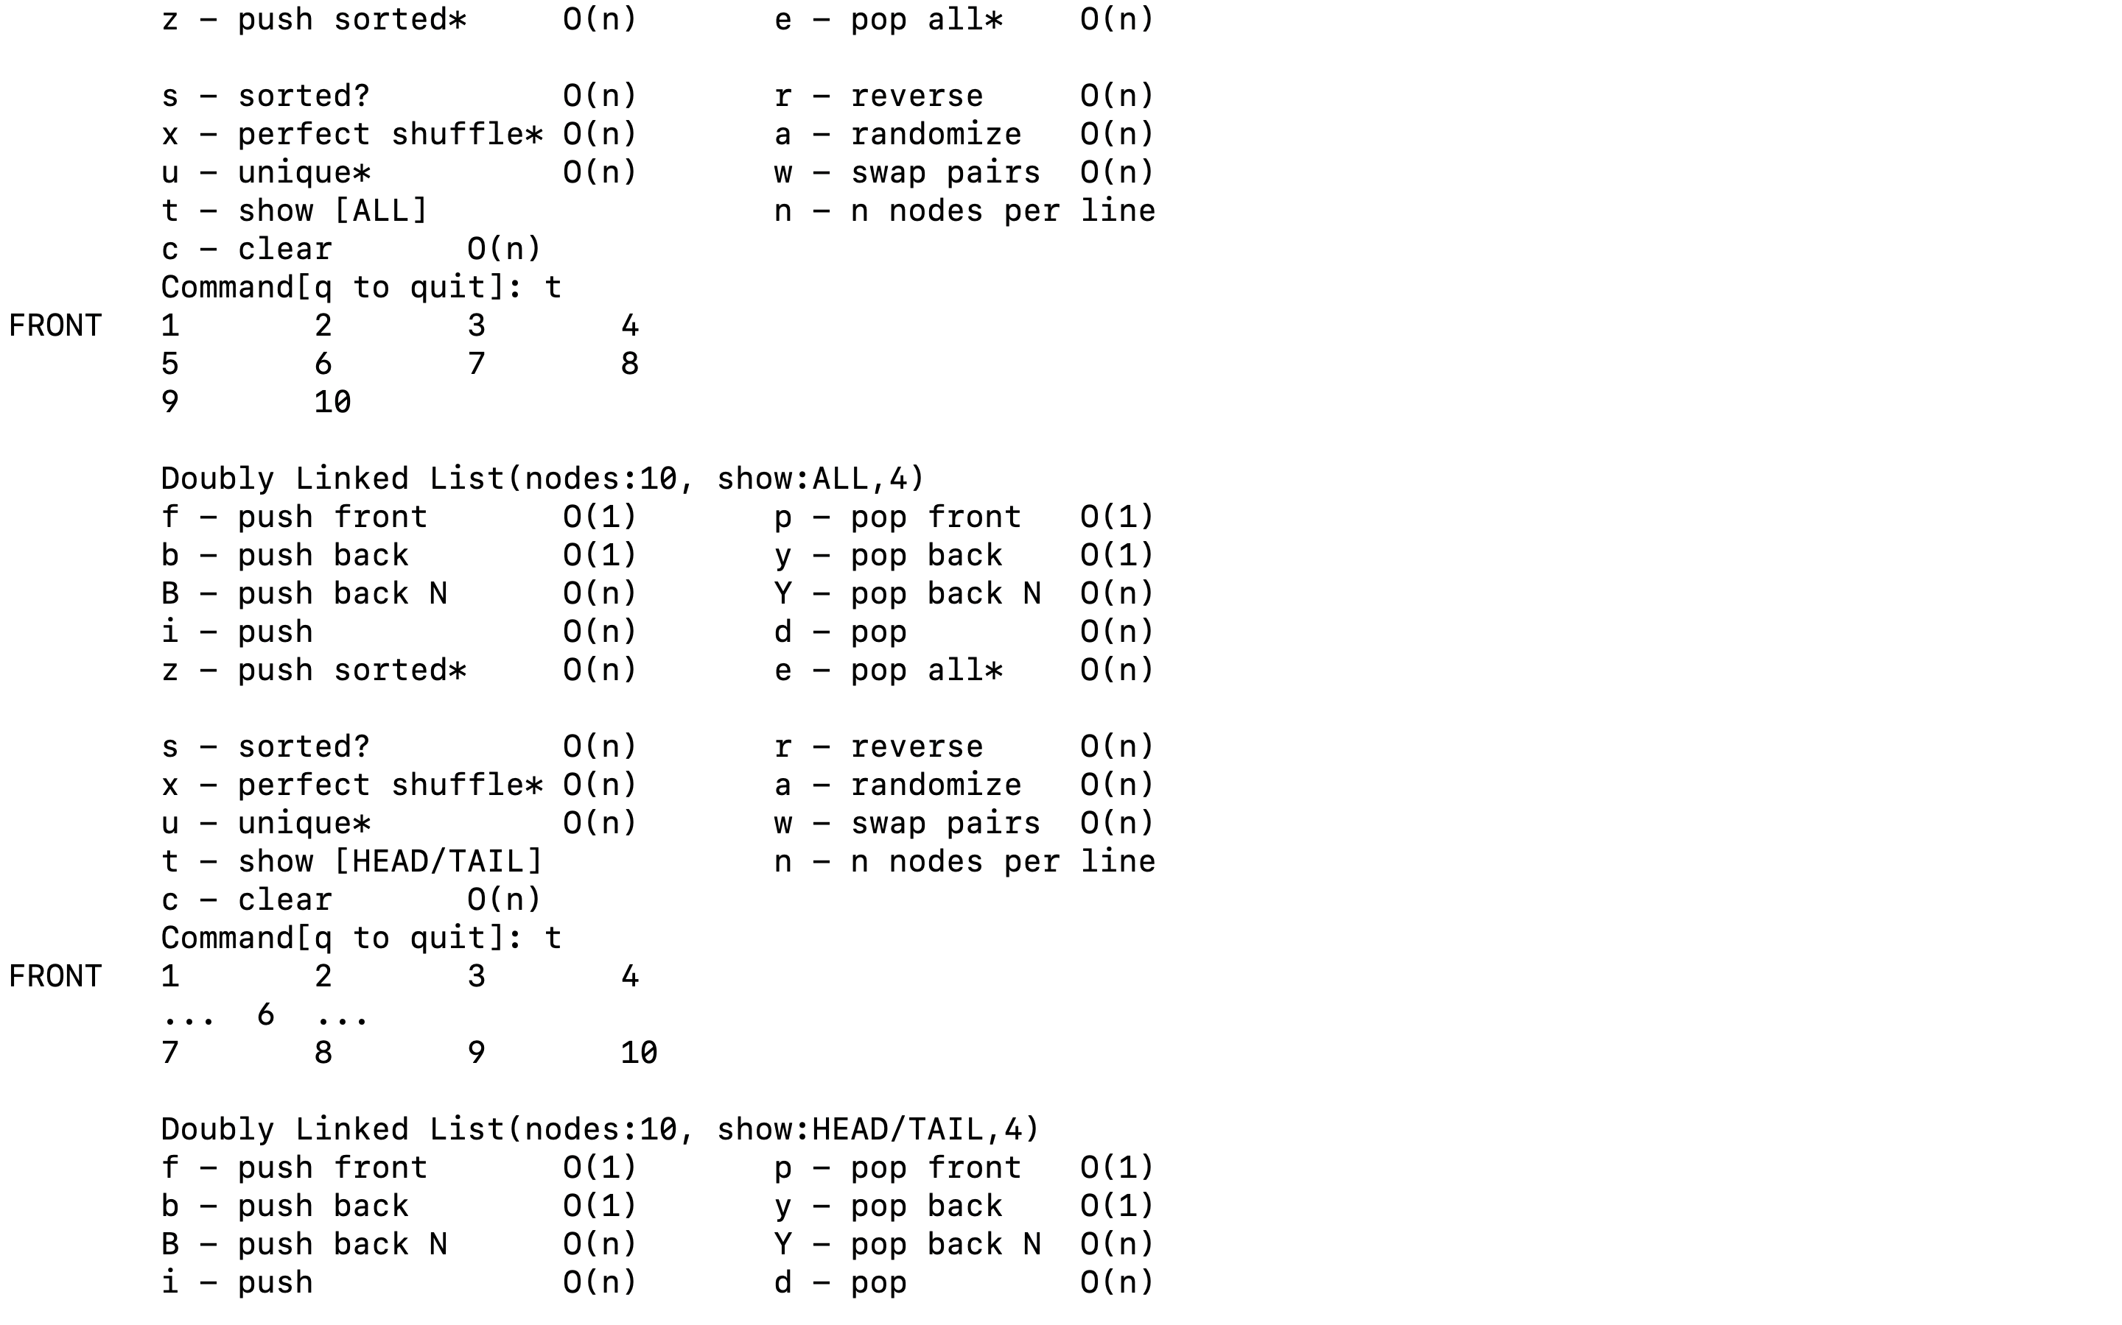

When list length is even number, the half node should be the first node of second half node.

We can see that it also work as intended.

There are two ways to implement half(). Both methods’ time complexity is O(n), but the second  
method is faster.

First method uses list’s size and goes through halfway using for loop.

Let me test it for 20,000,000 samples.

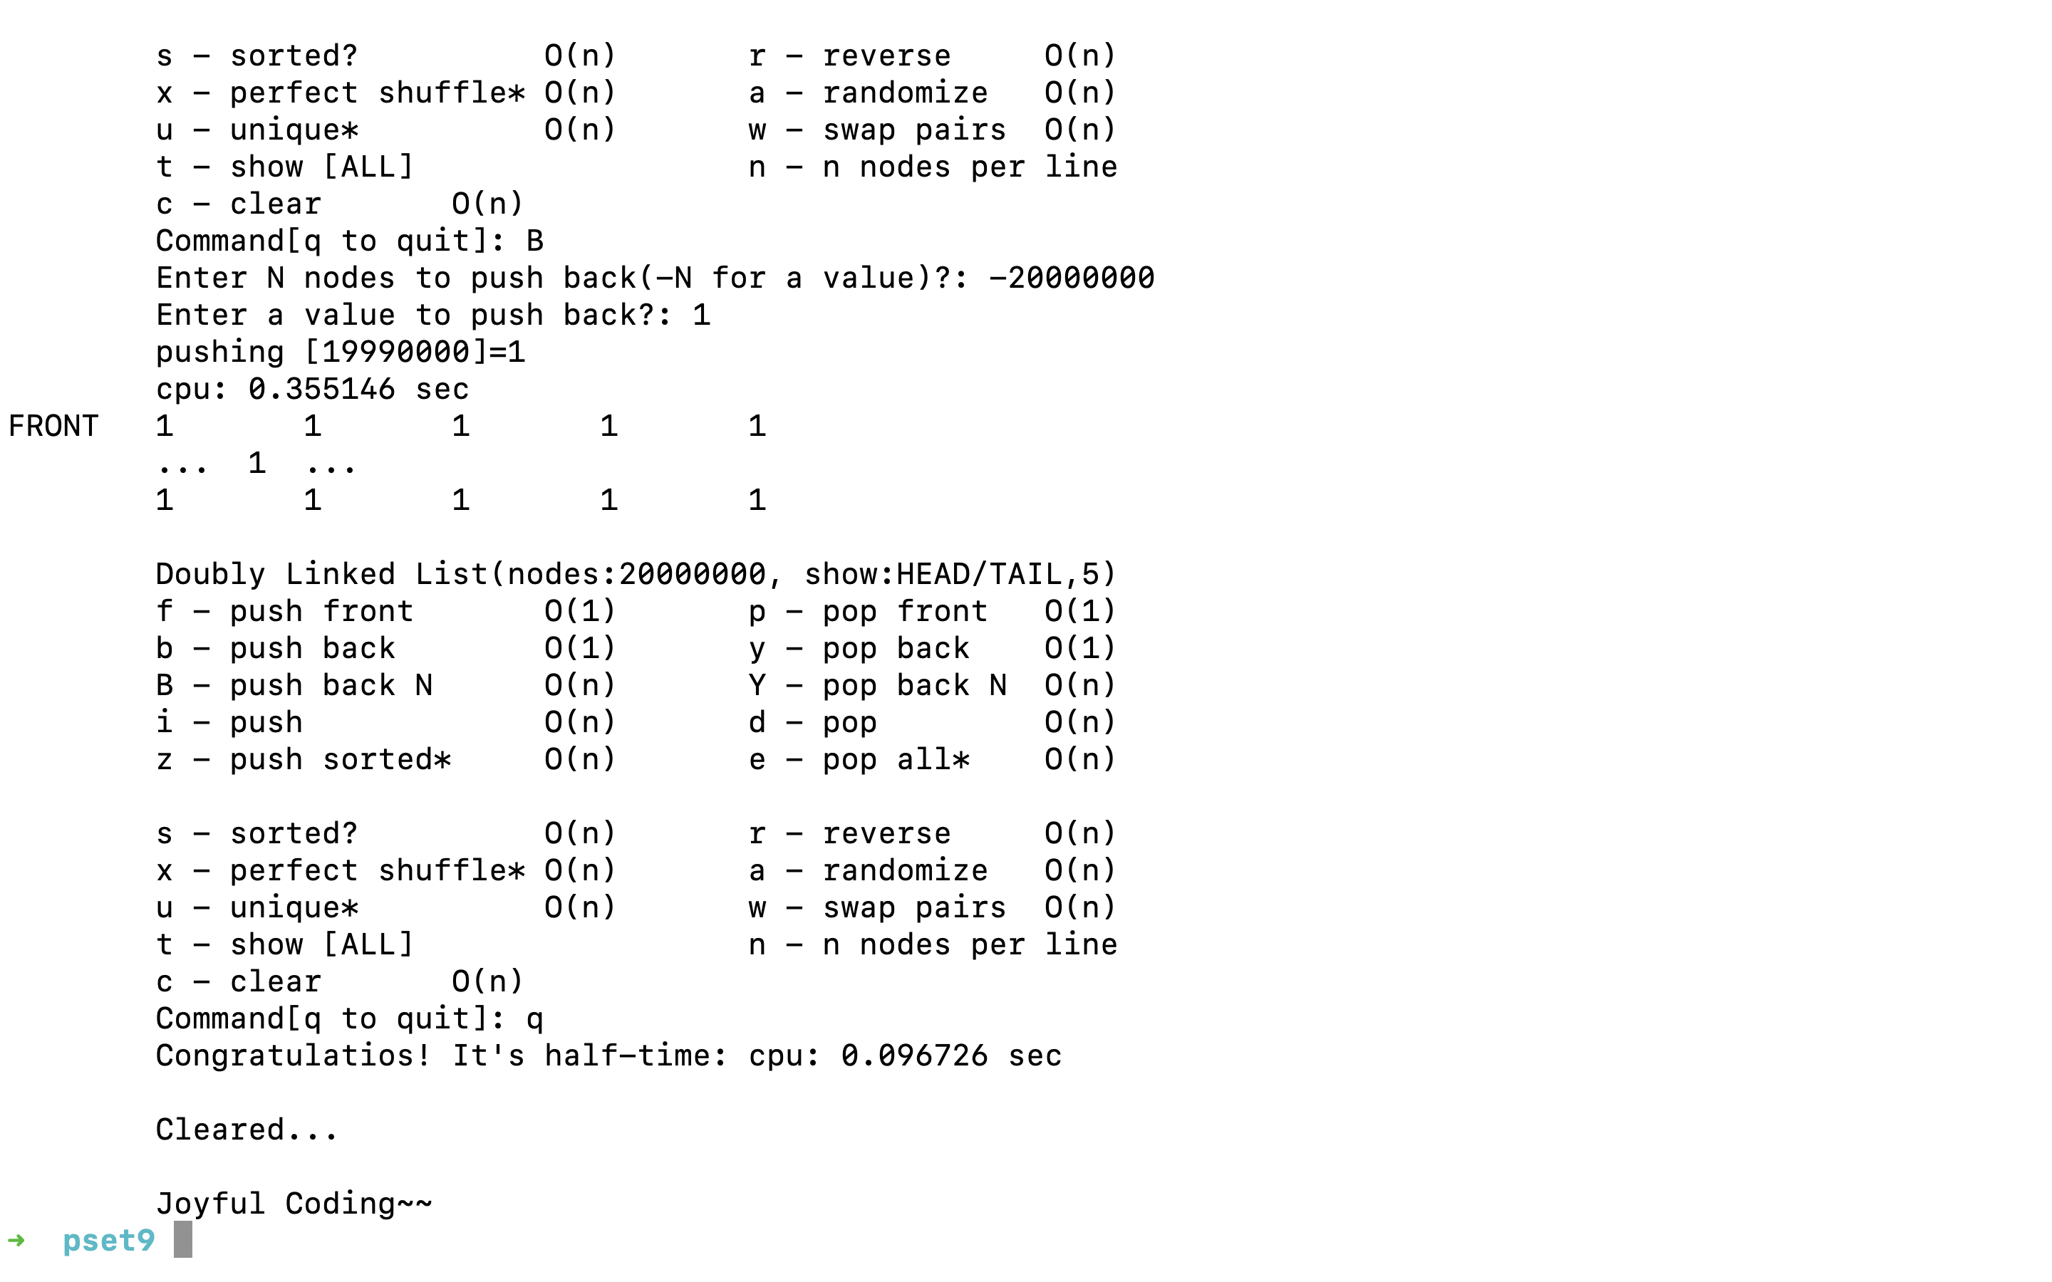

First method(for loop): 0.096726 sec

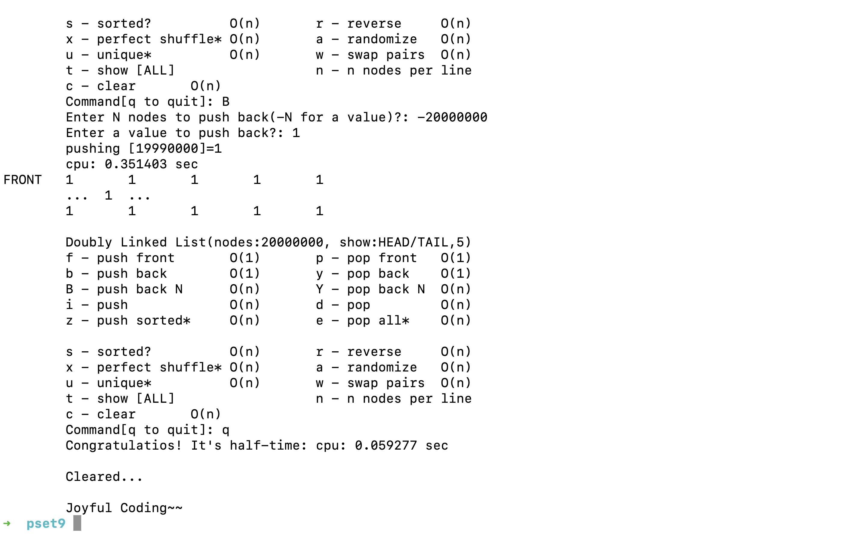

Second method(rabbit and turtle): 0.059277 sec

So the second method is about 1.63 times faster than the first method.

**sorted()**

checked by other operations ☺

**push_sorted()**

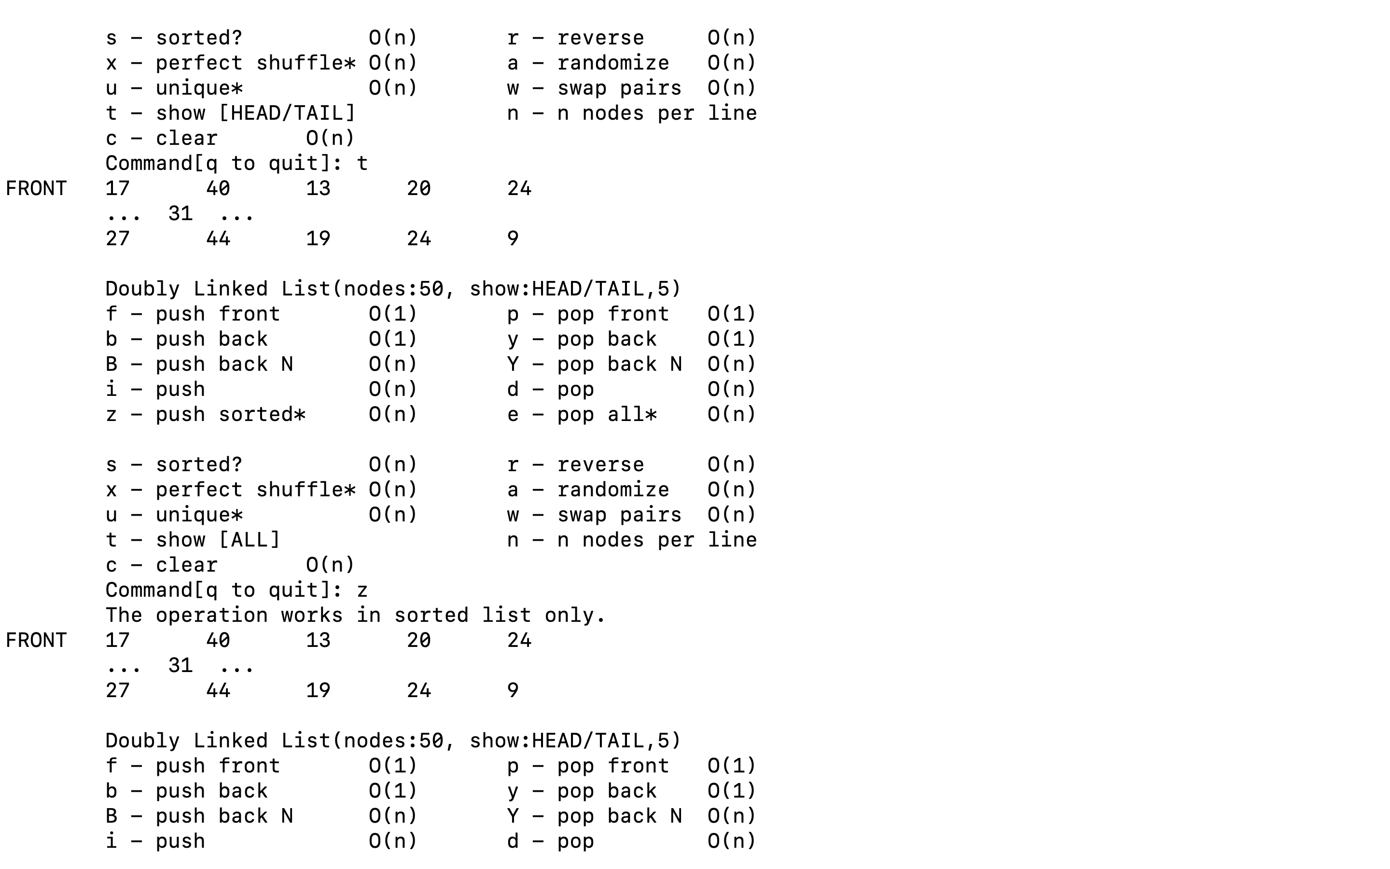

If we try push_sorted() with usorted list, it is not possible.

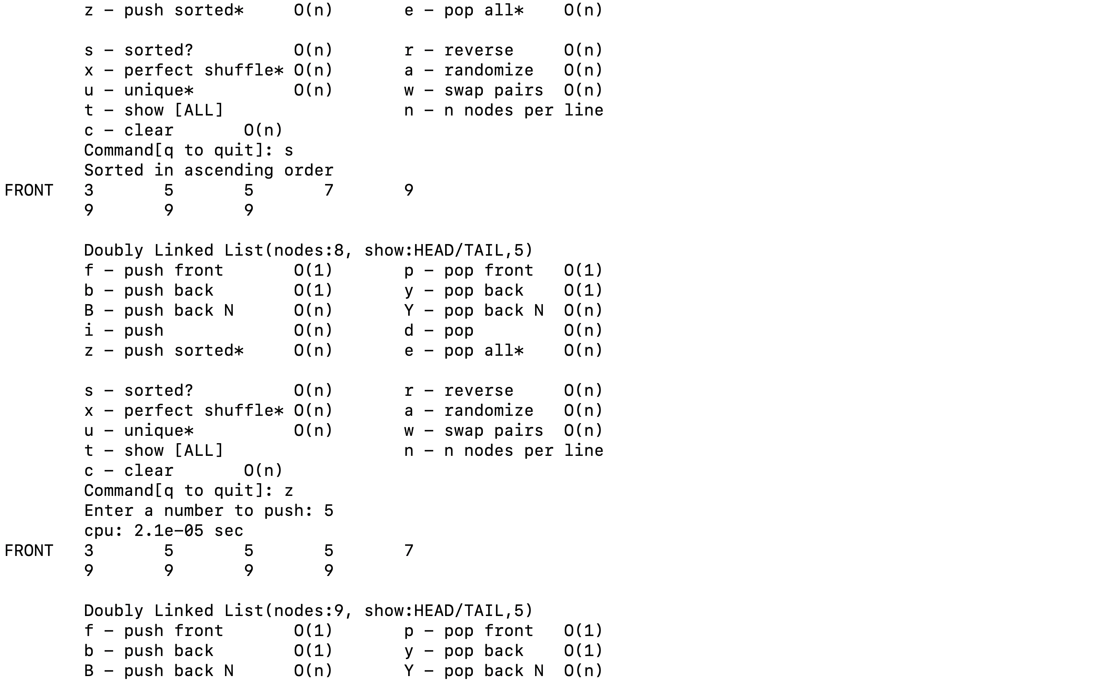

Since the list is sorted in ascending order, we can try push_sorted().

We can see that 5 is properly inserted.

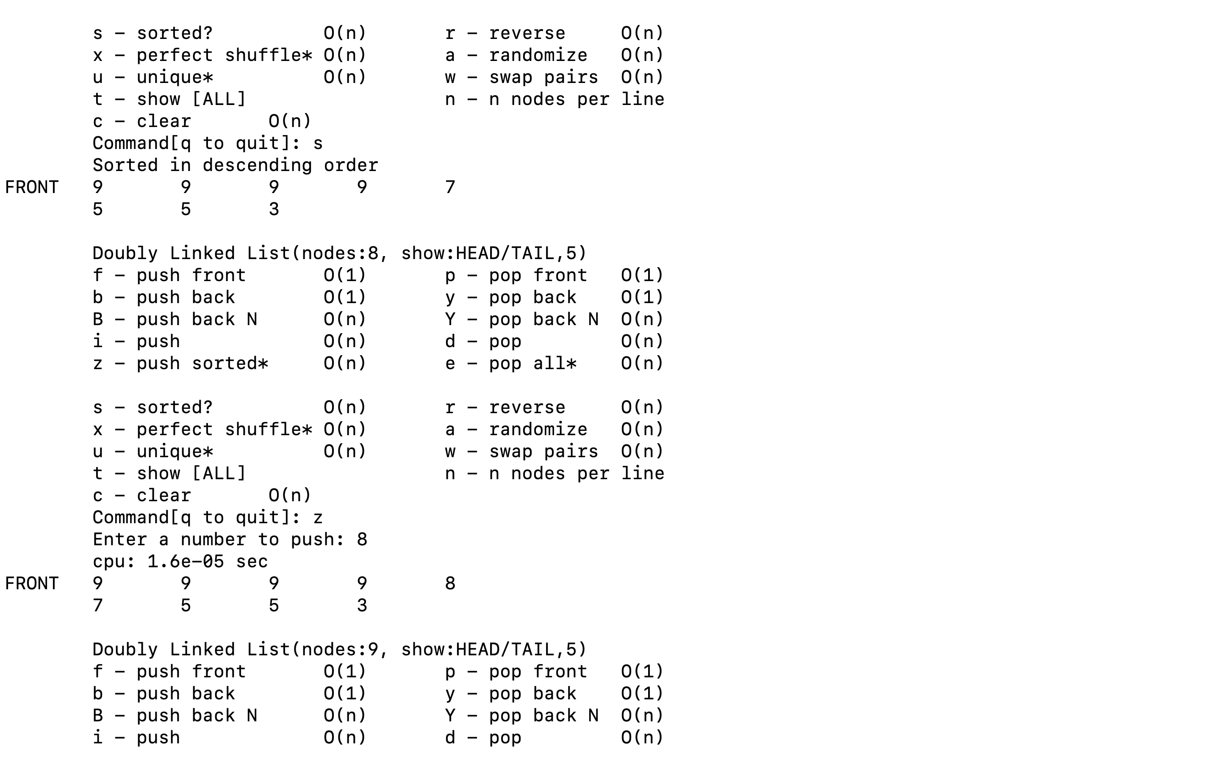

Since the list is sorted in descending order, we can try push_sorted().

We can see that 8 is inserted properly.

|  |  |
| --- | --- |
|  |  |

Result of testing with 100,000 samples.

**unique()**

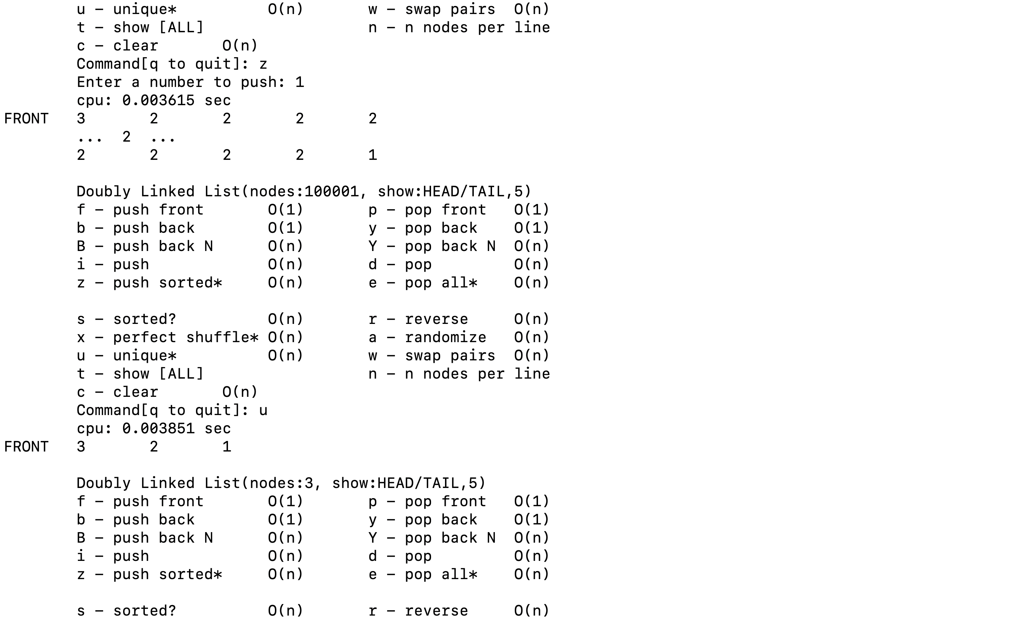

Testing with one ‘3’, 99,999 ‘2’s, one ‘1’.

We can see that all the ‘2’s are wiped out except one remainder. The existing bug is fixed by the same method of pop_all().

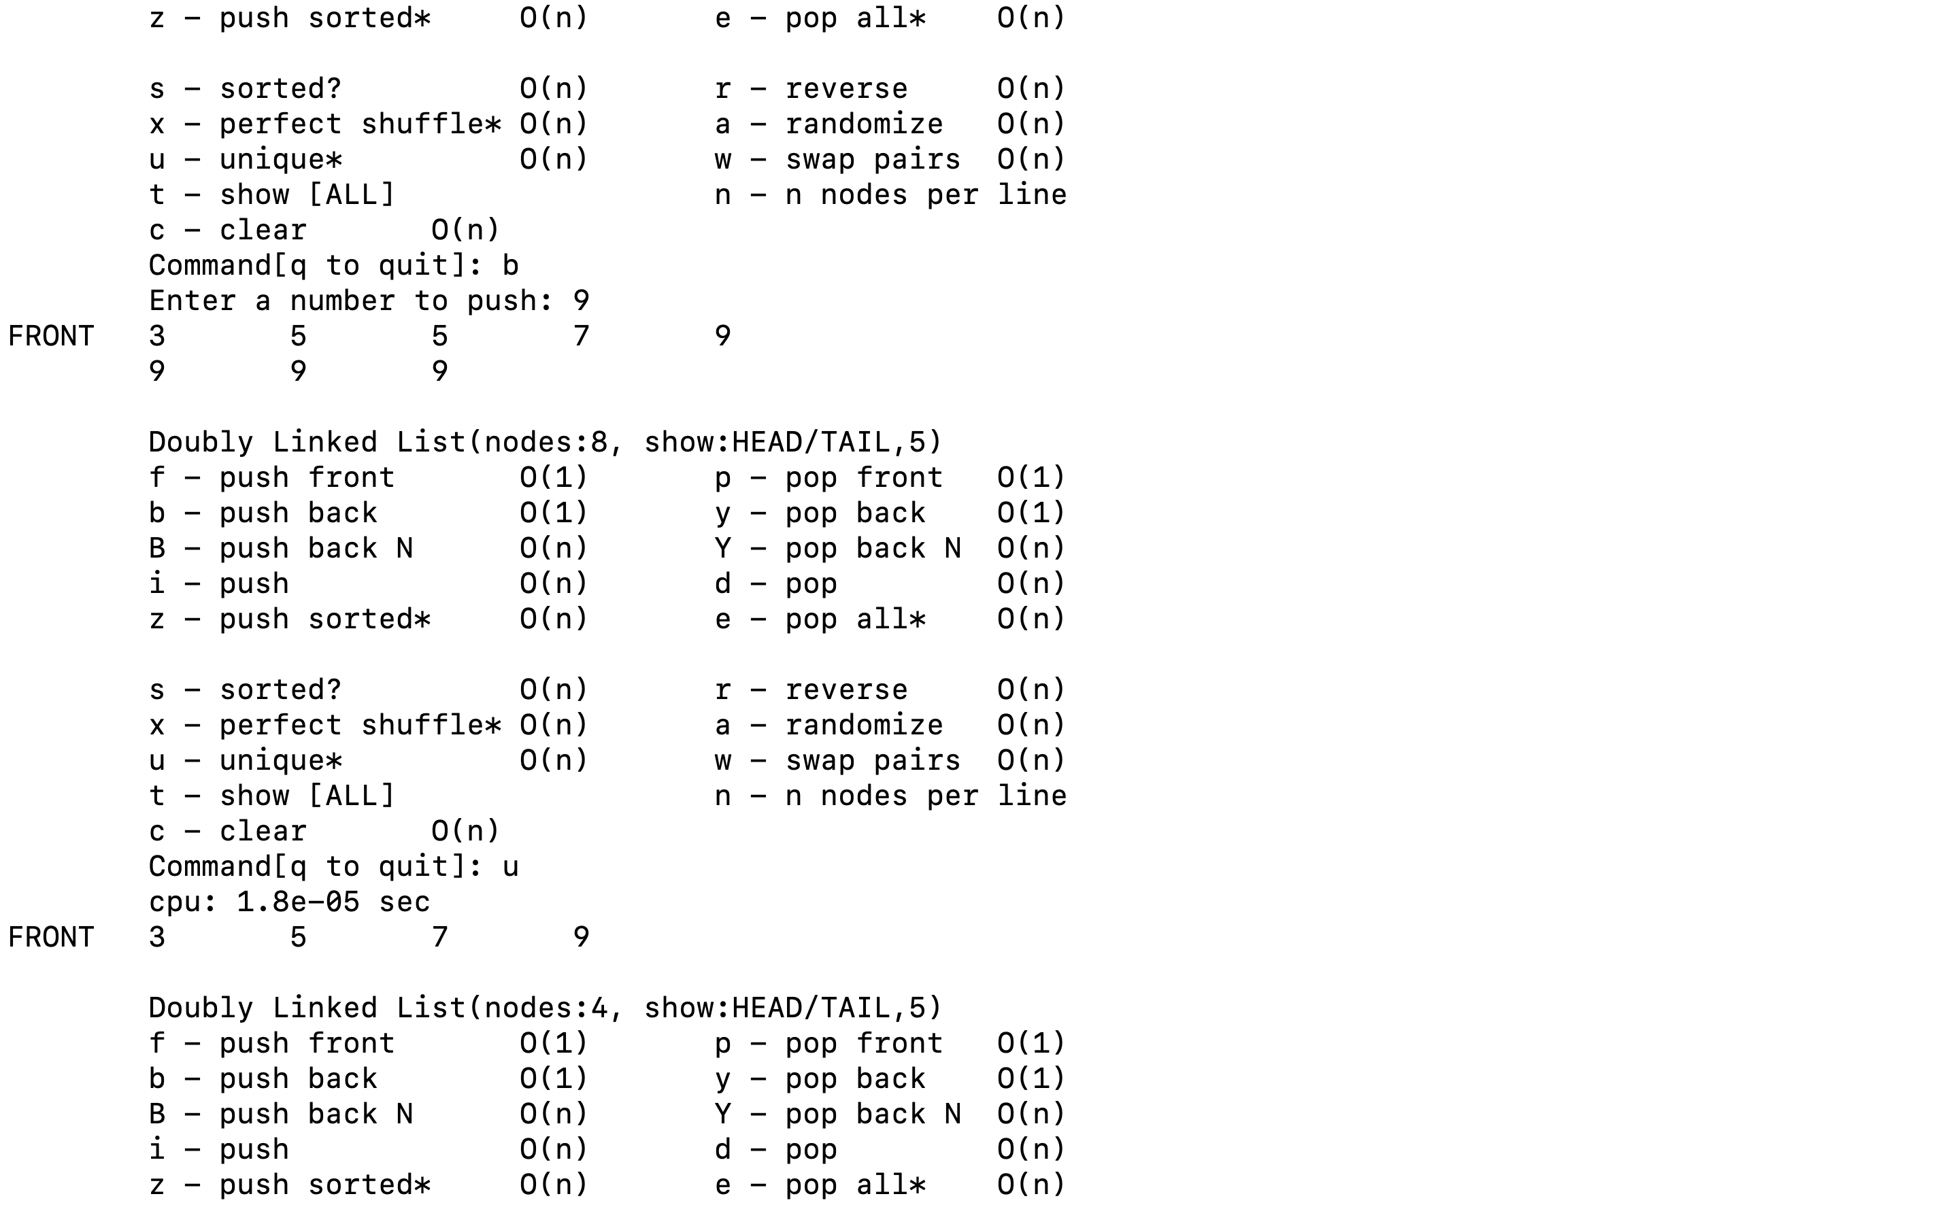

We can see that all duplicate number is wiped out.

11. shuffle()

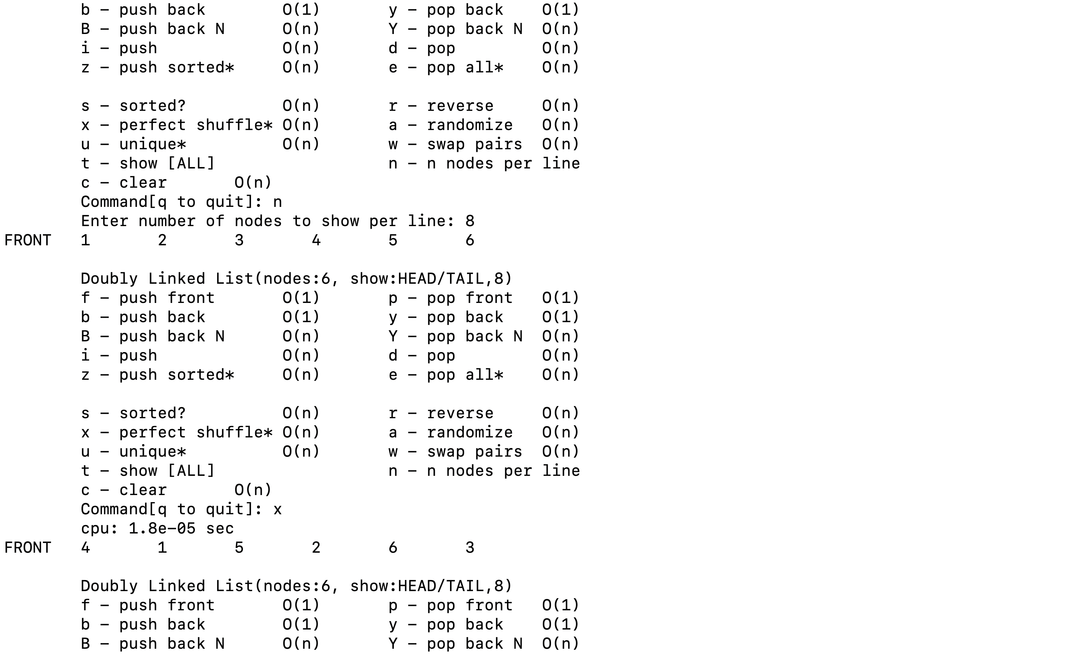

When list length is even number

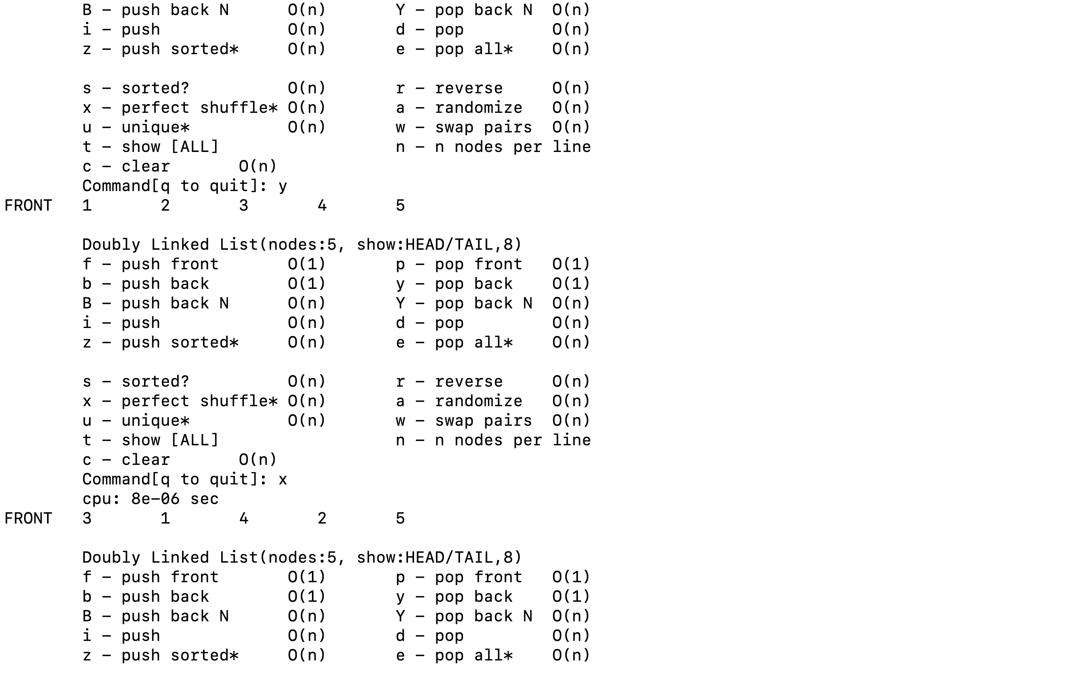

When list length is even number